GitHub Setup Lesson 1

* Go to github.com and sign up.

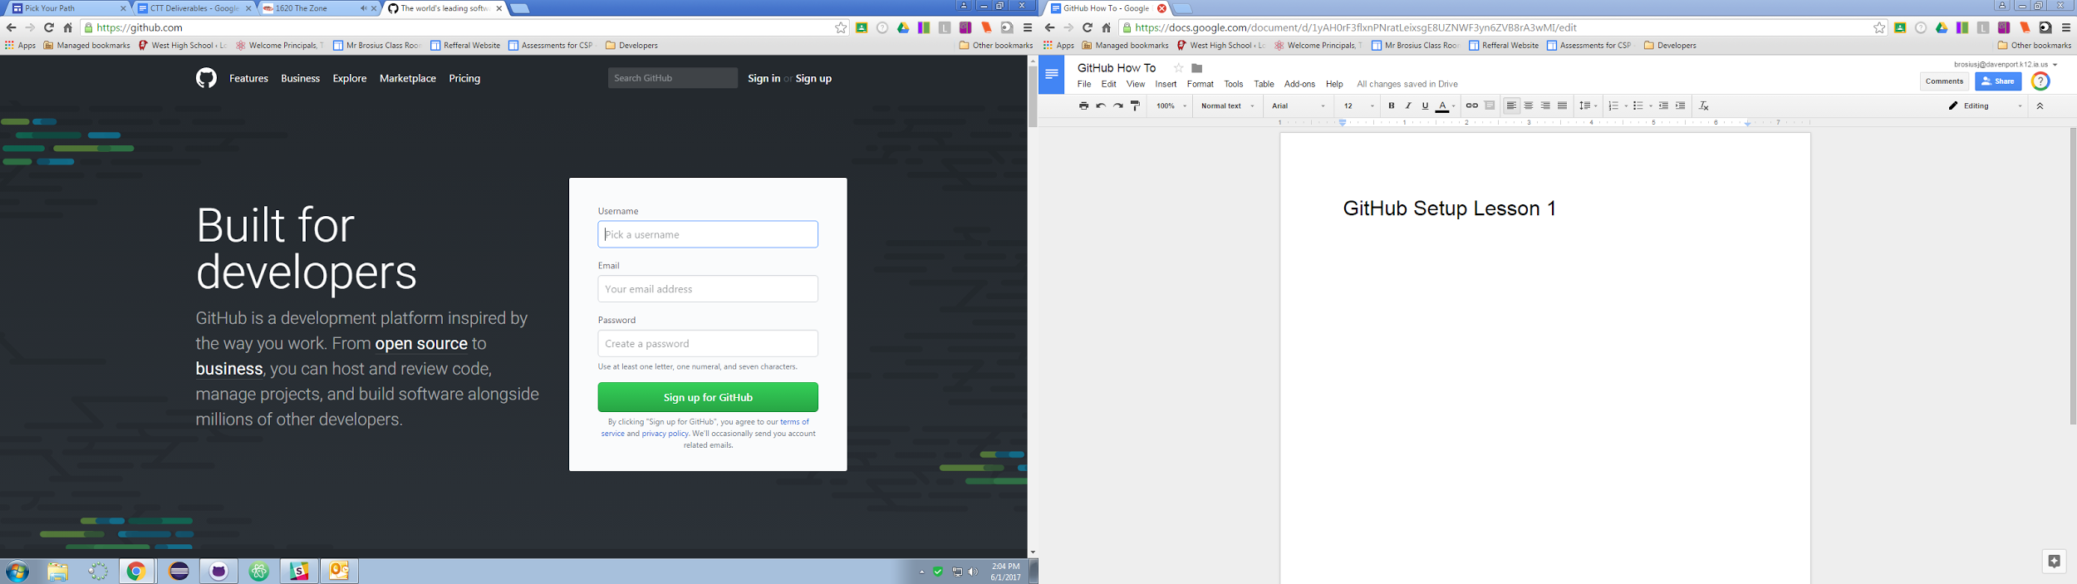

* Create a username and password that is professional and would be acceptable in a workplace setting.
* You will need to go to your email to accept and authenticate your page.

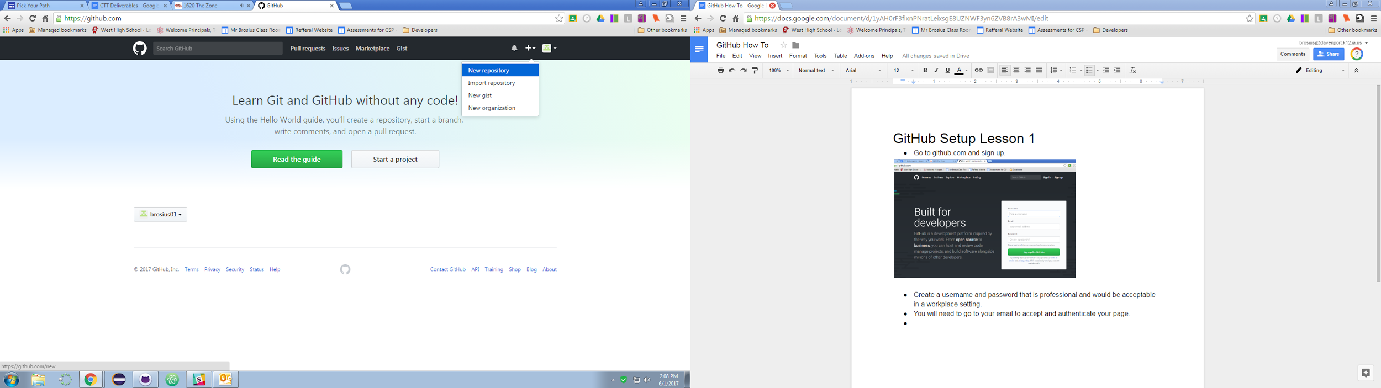

* Click new repository from the plus symbol on the menu bar.
* Create a new repository like Computer Apps I or whatever class you are currently taking.

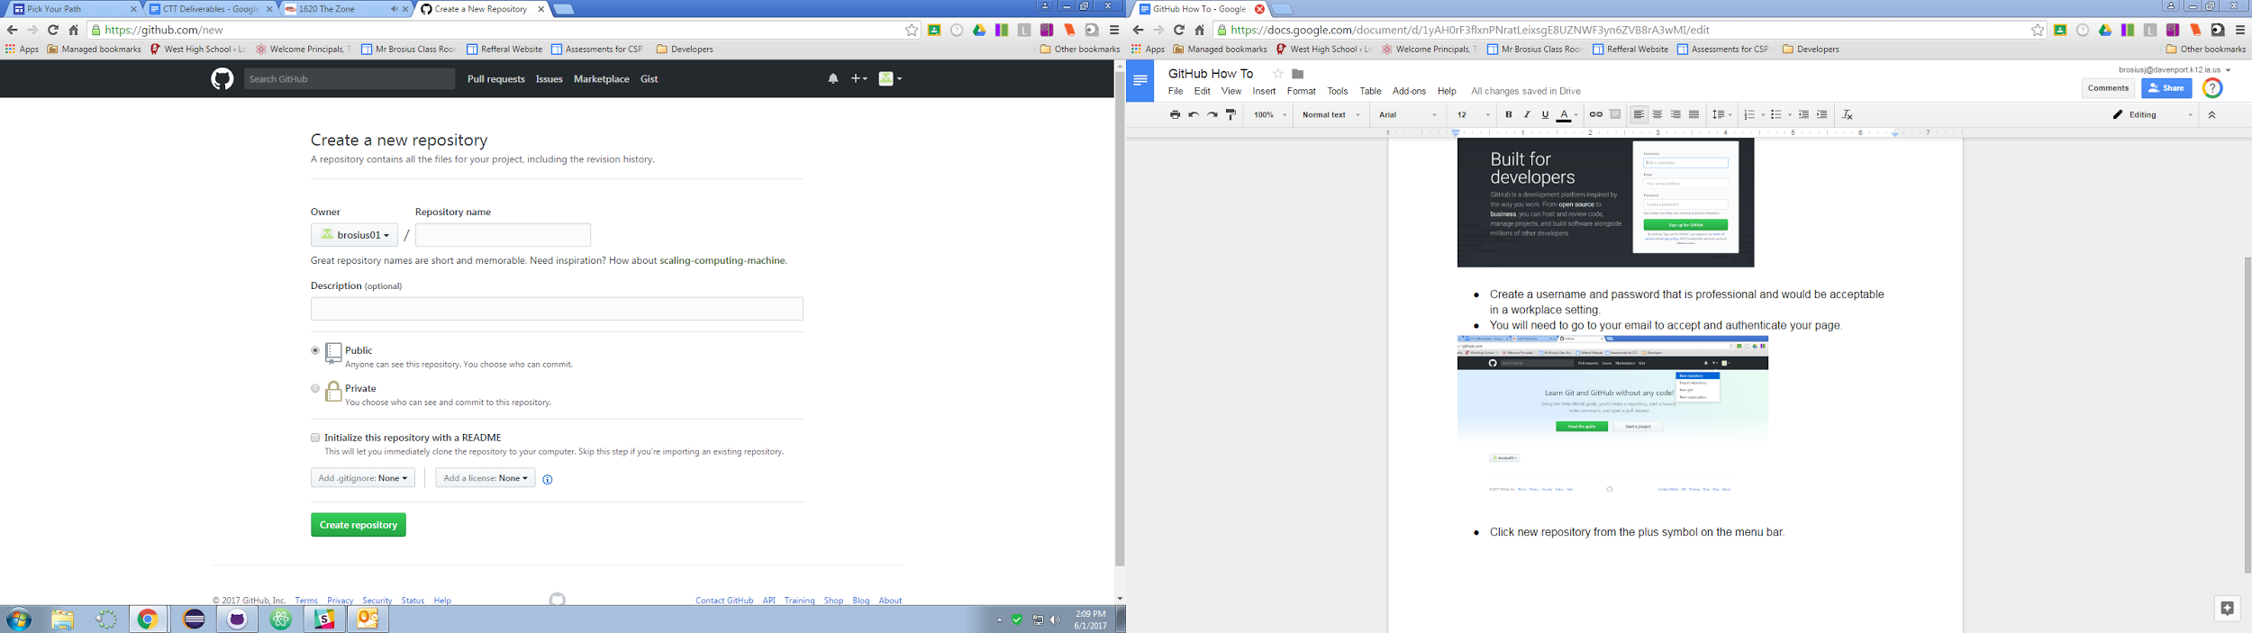

* Click the README box and then the green button
* If your screen doesnt look like this after hitting the green button you set it up incorrectly.

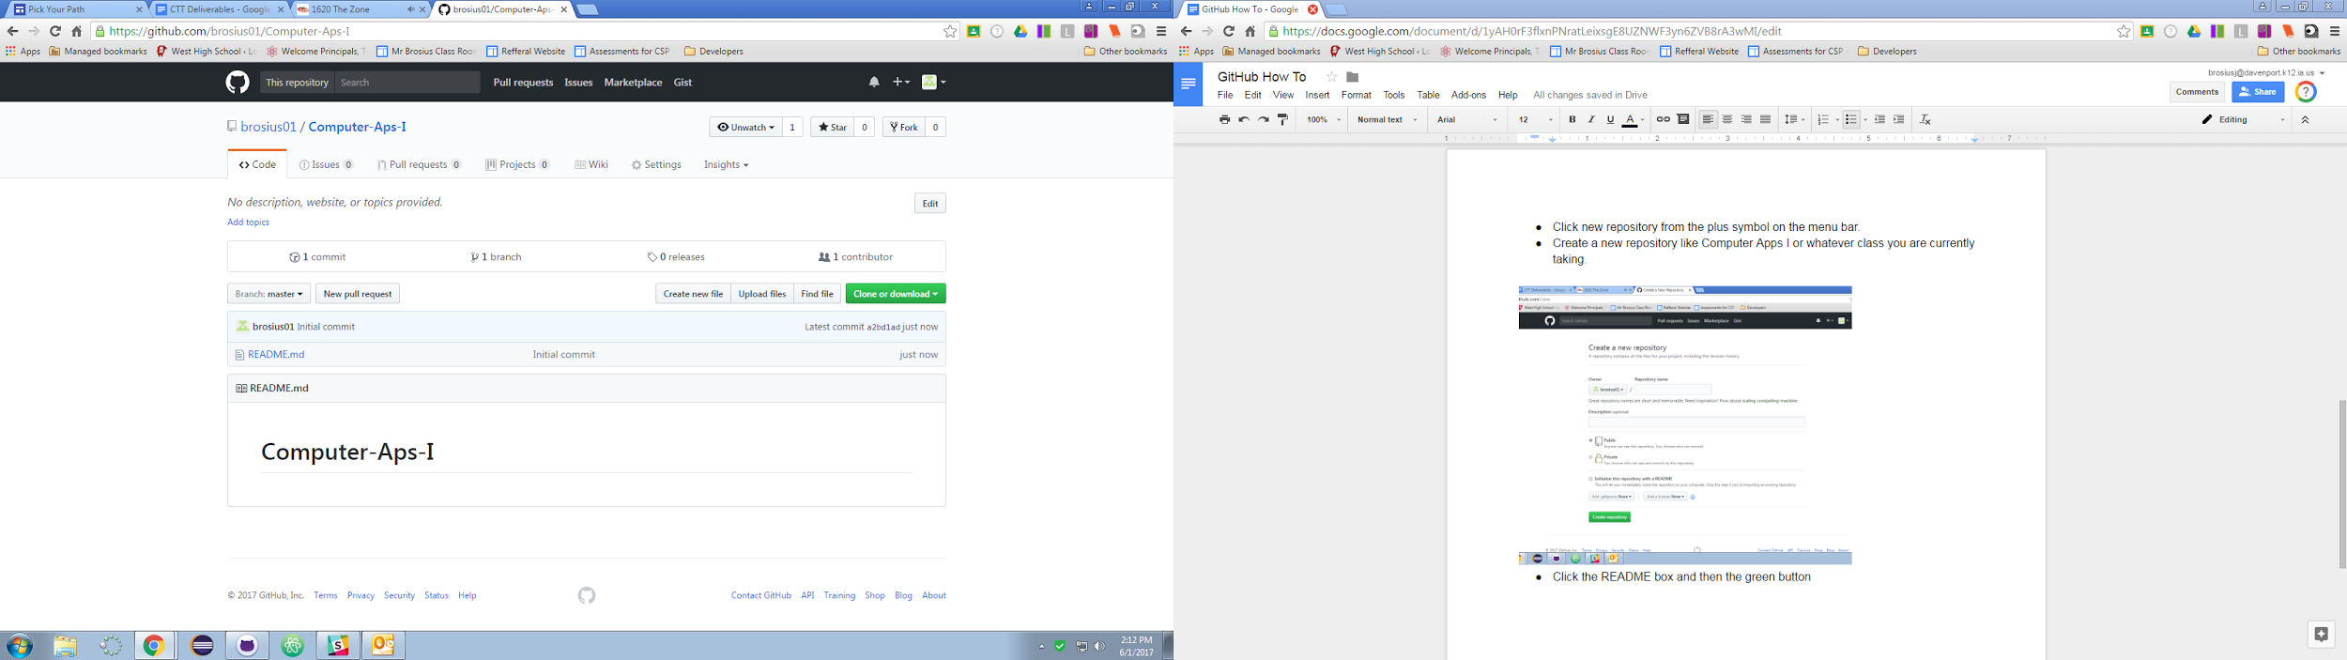

* On your desktop create a folder called Computer Applications by right clicking on the desktop << new << folder.

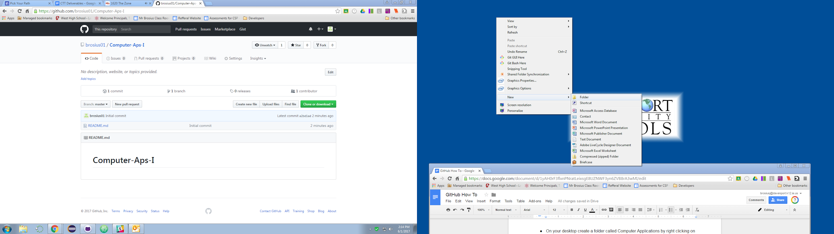

* Create three other folders inside of the new folder you just created.
  + Microsoft Word
  + Microsoft Excel
  + Microsoft Powerpoint

